**08-28 Homework – Excel**

Each of the following problems requires at least one excel sheet. The problems also require writing and thinking. Please turn in complete Excel sheets and your writing and thinking (pdf scans of work preferred, heic/tiff/jpg images don’t always turn out well. I think Microsoft Lens and/or Microsoft Journal are great and easy).

I look forward to seeing what you turn up!

1. Sometimes, the force of fluid “air” resistance can be described as $F=-b⋅v⋅\frac{v}{\left|v\right|}=-b⋅ v⋅ \hat{v}$, where v is velocity and F is force. This description is often correct for things that are small and slow-moving (ie, not cars or rockets, maybe butterflies)
   1. If you’re working in meters, seconds, and Newtons, what are the units of b?
   2. If the velocity of a 10 gram acorn is initially -10m/s (downward, up is +y), the non-relativistic version of Newton’s second law $\frac{dP}{dt}=\frac{d mv}{dt}=F_{ext}=-b⋅ v⋅ \hat{v}$ is reliable. In terms of initial velocity v0, initial position x0, b, and t, what equations will describe the position and velocity of the acorn?
   3. If the acorn slows from -10m/s to -6m/s in 2 seconds, what’s the value of b?
   4. Use the equations from b (above) and excel to make a data table for the acorn, showing time, position, and velocity and time increments of 0.1 second from 0 to 2 seconds. (so about 20 rows?)
   5. Use excel, and the equations from b&c (above) to make a second data table showing time, position, and velocity, at constant position increments that give about 20 rows of data and 2 seconds of motion.
   6. What average speed does an integral of the equation in b give for the first 2 seconds of the acorn’s motion?
   7. What average speed does the average of the speed data in d give? Does it match f.
   8. What average speed does the speed data in e give? Does it match?
2. Go to a Grocery Store, or Kwik Trip, or Menards. Online grocery stores are ok, I guess.
   1. Collect data for 10 items you would eat. For each item, record:
      1. total price
      2. kcals/serving or Calories/serving
      3. number of servings
      4. %Daily Value of Salt/Sodium
      5. %Daily Value of Saturated Fat
      6. USDA Food group (veg, fruit, fat, meat/dairy, etc)
   2. Organize this data into an Excel Table. Make sure you have column headings and include units. Don’t attach units to numbers – instead put them in the column numbers.
   3. Create a (calculated) column in the sheet, showing the total number of Calories/kcals in the item’s package (example: how many kcals are in an entire box of spaghetti or a whole loaf of bread?)
   4. Create another calculated column in the sheet, showing the kcals/$ figure for each food item (eg, 1200kcals in a loaf of bread/$3.49 = 344kcals/$)
   5. The USDA Food Stamps/WIC/SNAP programs estimate that you can live on a grocery budget of about $5/day. Does your data bear this out? Create another column that uses a Boolean IF statement that shows if a food item lives within (is cheaper than) the USDA 3000kcals/$5 budget.
   6. Create a histogram (see the Excel help for this) of kcal/$ rates for your food items. Make sure this histogram has meaningful captions and labels. Make sure the horizontal scale includes/shows the 600kcal/$ mark.
   7. Use your data to check/fail the following hypotheses:
      1. Cheap food is not salty
      2. Cheap food is high in fat
      3. Cheap food is typically in the vegetable group
      4. Or Make your own based on what you observe
3. Wikipedia has lists of lists of lists online at <https://en.wikipedia.org/wiki/List_of_lists_of_lists>
   1. Pick out a list that you think is fun. The list must include numeric data. Example: Lakes in Papua New Guinea <https://en.wikipedia.org/wiki/List_of_lakes_of_Papua_New_Guinea>

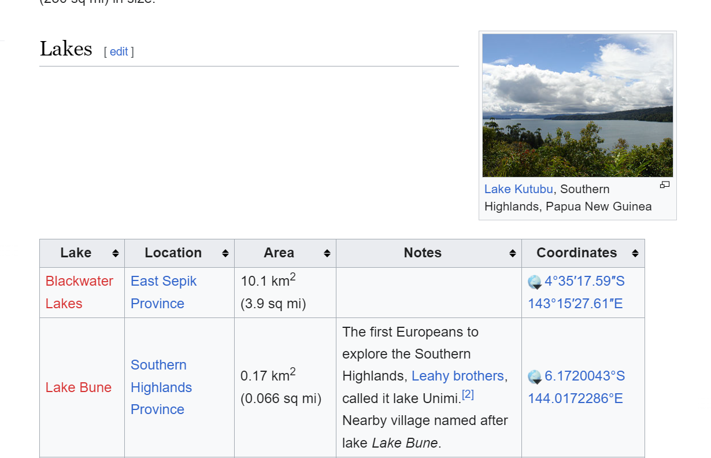

* 1. Click-drag-highlight-copy-paste the table data in your list into excel.

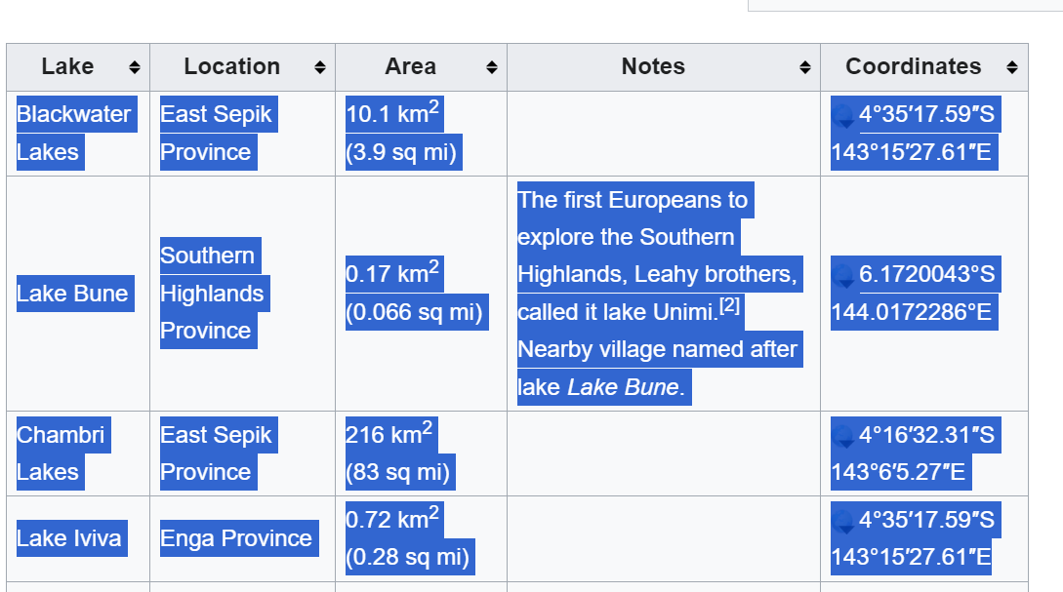

* 1. Select all cells in the excel sheet and “remove hyperlinks” 
  2. Use Data>Text to Columns to strip the numeric data of units and footnotes.

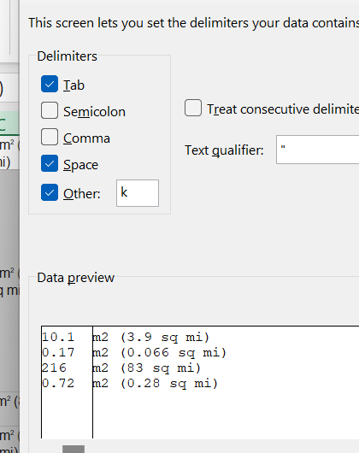 

* 1. Create a Histogram of the column of numeric data in your list. Format axes labels. Comment on any trends you see in the data – is it Gaussian/Normal? Are there multiple peaks? Are there easily explainable trends?